 **Sample Deal Sheet March 17, 2024**

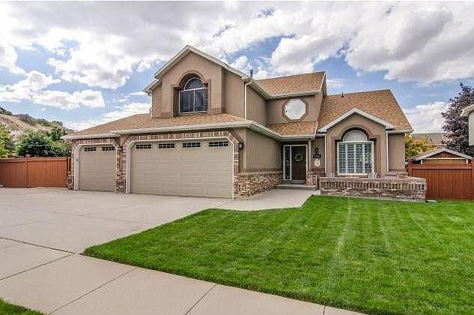

[Zillow Link](https://www.zillow.com/homes/6736-s-Benecia-drive-cottonwood-heights,-ut_rb/12872757_zpid/?)

|  |  |
| --- | --- |
| **Property** | **Loan** |
| **Address**: 6736 S Benecia Dr, Cottonwood Heights, UT 84121  **Zillow estimate**: $938,600 **Type**: Single family  **Configuration**: 5 bedrooms, 4 bath  **Square footage**: 2,617 **Price/square foot**: $359  **Condition**: Very good **Year built**: 1993 | **Purpose**: Cash out  **Loan amount**: $650,000  **Term**: 2-years  **Rate**: 10% (net to investor)  **Prepayment penalty**: Yes; 1% of loan amount  **Monthly interest payment**: $5,416.67 |

|  |  |
| --- | --- |
| **Borrower** | **Underwriting** |
| **Address**: Bill & Sally Smith  **Credit score**: NA  **2023 AGI**: $114,138 **2022 AGI**: $109,394  **Debt to income**: 33%  **Exit strategy**: Refinance  **Condition**: Very good **Year built**: 1993 | **Appraisal type**: Broker’s opinion  **Broker’s price opinion**: $945,000  **Net equity value**: $295,000  **Loan to value**: 68.6%  **Net equity percent**: 31.4%  **Prepayment penalty**: Yes; 1% of loan amount |

|  |
| --- |
| **Additional Notes** |
| Bill has worked for the Salt Lake School District for 14 years; Sally is a self-employed hairdresser. The loan proceeds will be used to finish repairs to a rental property they own in South Jordan, which they plan to sell next year. Their net worth statement reflects $987,000, which includes various retirement accounts. |